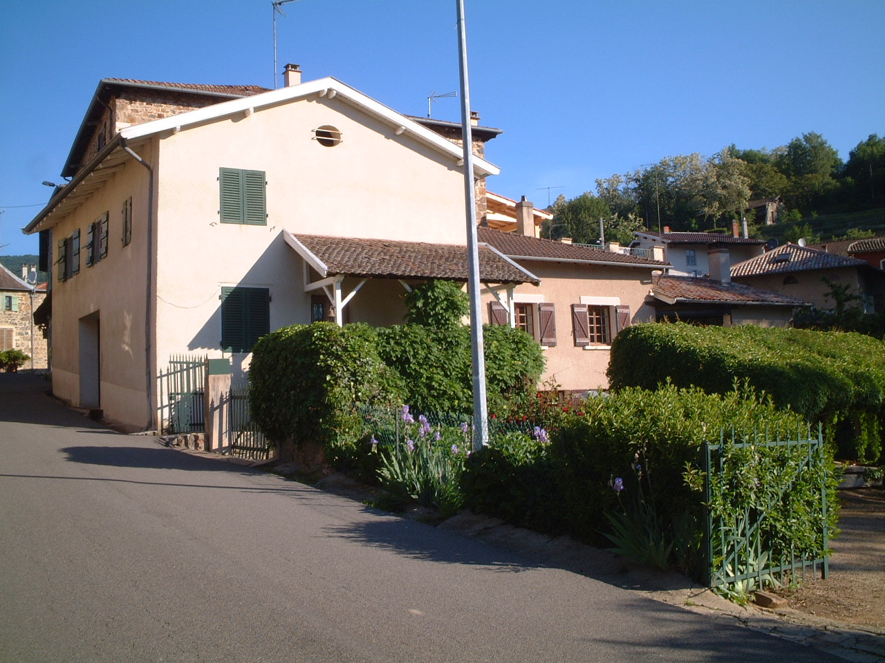
A Guide to Marchampt.

On arrival
A torch is handy if arriving late.

The gate into the house can be a bit tight depending on what car you have, it may be easier to pass the house and turn in the recycling area just beyond the house and approach from the other direction. Just as you drive in the gate on the right there is an electricity or water tap ~~~~~~~~~~JOHN TO COMMENT covered, to protect it, by an orange plastic. LOOK OUT

The two keys you have open both the shutters and main door behind them.

Shutters & Keys etc. Key to double doors in kitchen are by the phone and in the lounge the key is on the mantle. You may want to shut the downstairs shutters at night and when you go out for the day, not just for security but it also keeps the house cool. In the kitchen the small window over the sink doesn’t open fully due to the tap and it’s really hard to reach the shutter handle (sit on worktop at stretch!), so don’t bother to fasten these shutters from the inside except when closing up the house when you leave, so just push them too and pull them open from the outside There are electric shutters in upstairs bedroom above tv/lounge/dining room – remote control on bed. Please shut all shutters when you leave. Key box on wall in entrance. Find key to cave here – mind your head ceiling is low and the light switch is above you. Switch for large security light outside is just inside main door entrance. Another outside light switch is in the lounge.

Entrance to old Farmhouse side of the house is via main entrance in new side. If you want to open up old side kitchen door please do, there is a table on the porch, nice cool spot to sit and it gives a nice breeze though the house. Keys are **********************?

Bedrooms There are three bedrooms in the Farmhouse two interconnecting doubles and a twin. Spare bedding is in each room. The forth room is a storage room, if you want to move anything out of the way, put it in there but make sure the door is shut as this room leads to the attic. The cats next door have been known to get into the attic space via Mr Gouls attic. This isn’t a problem unless the attic and the storeroom doors are left open.
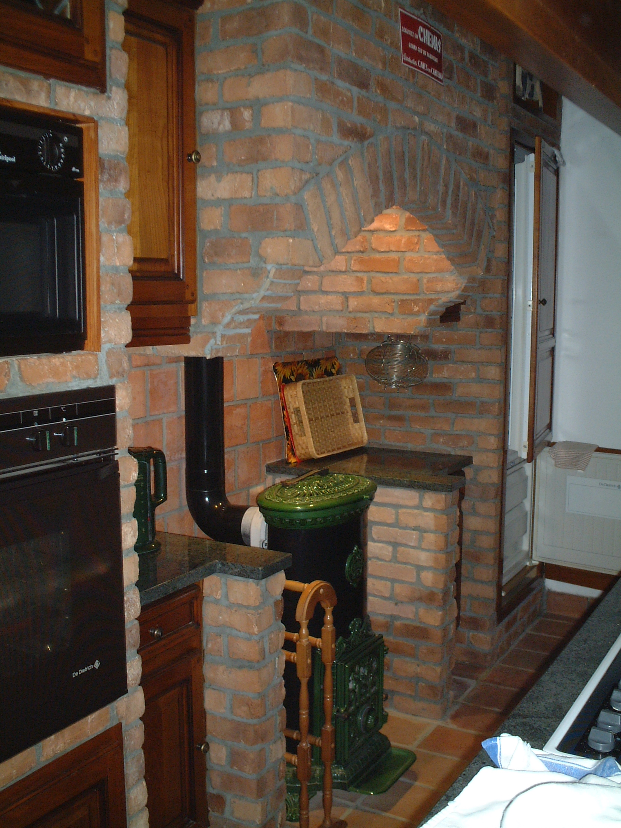
Bathroom with shower on Farmhouse side, another with bath and shower and upstairs toilet in New side.

Kitchen.

Power for fridge in lower cupboard next to fridge.

Power for microwave in lower right hand cupboard next to oven. Power for oven and halogen hob also in this cupboard.
Cleaner for halogen hob under sink, scraper if needed in drawer under hob. Microwave has false base, if you have a major spill in there lift up base. There isn’t a turntable – I was surprised too.
Extractor rather low, tall people mind your heads on the corners. Power sockets on island handy for toaster/mixer/coffee machine etc.

There is a large basket full of corks. This keeps Ryan occupied for hours, feel free to add to them.

Dishwasher – salt, rinseaid and detergent under sink. Door is really heavy and will drop unless lowered. Extra fridge/freezer in entrance if you need it.

Large chest of drawers by bathroom. Large table wipeable table cloth for patio table (stops glare from sun). napkins etc. Games etc. Small mirrored cupboard. Spare towels and linen
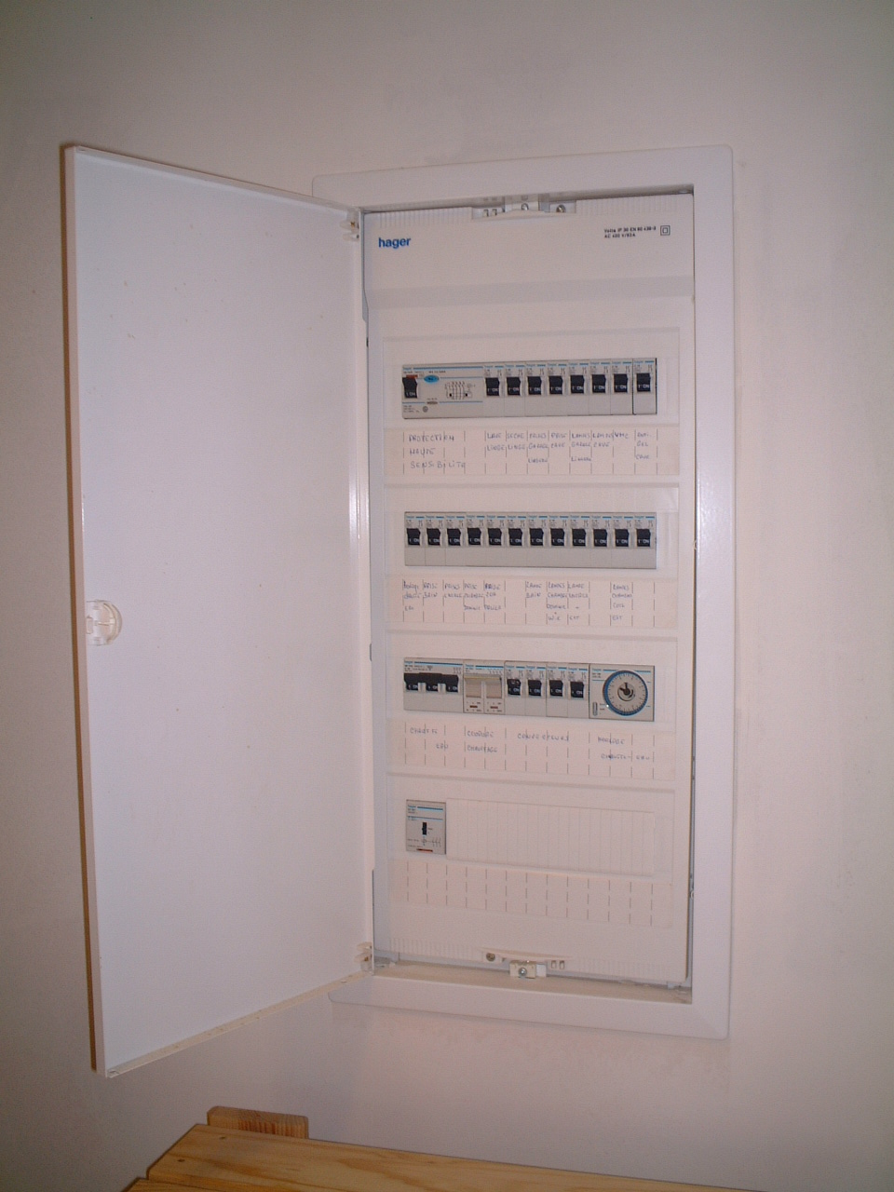
Laundry Room. Washing machine and Dryer instructions are there. As a guide D is the program for general washing - bedding, towels and clothes - and has a very fast spin. K is the more delicate wash but will stop after the wash cycle and you have to manually turn dial one notch for drain and spin (slower). Dryer is a condenser and you need to empty water container pretty much after each load. There is a vine planted by the trellis next to the cave door, I empty the water container there to ensure it gets some water! In summer can you water it now and again? Thank you. Clothes drier in entrance hall for use outside or there is washing line under the vine covered shelter. Main fuse box is located here – if power goes try here first.

Mains water tap is in the cave at the back and is labelled, should you need to turn off the water.

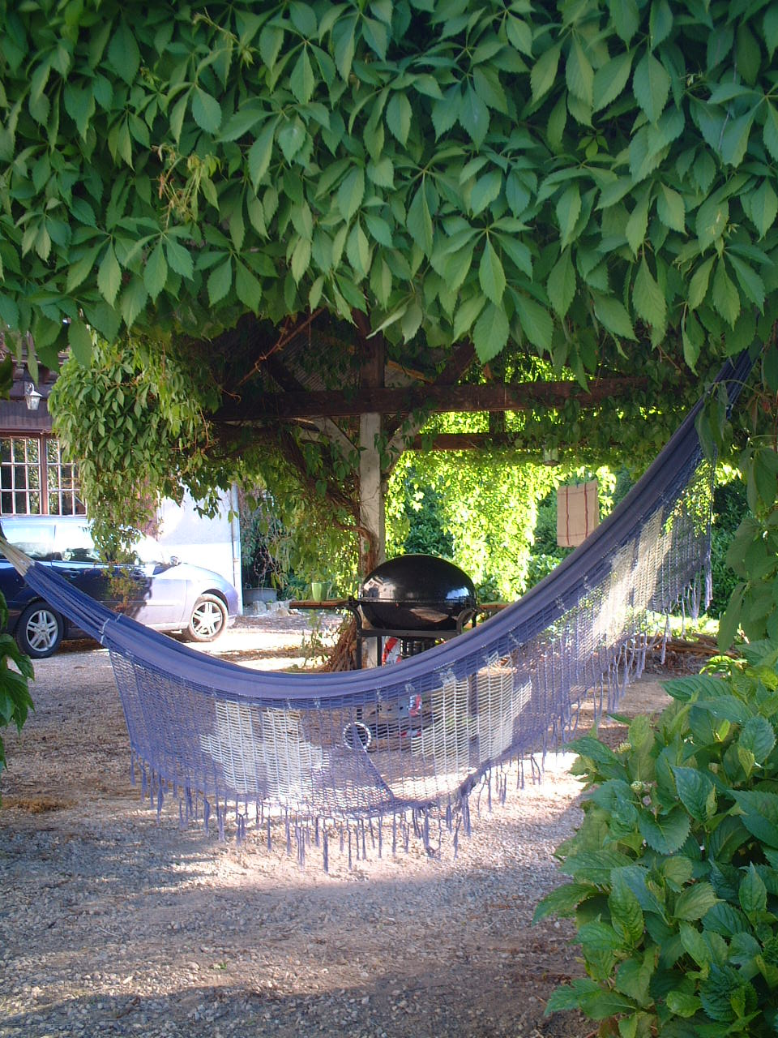
Septic Tank. Normally not a problem! In new side bathroom in small cabinet there are sachets of powder to empty into the toilet and flush away – these ensure there is enough bacteria in the septic tank to do its job. However, if the house has been empty and then a large group arrive it may need another sachet or two. If you start to smell parsnip/root vegetable around bathroom or just outside main door (tank is located beneath manhole cover) then pour in a sachet and flush. Sachets will have been put in before you arrive. If you are closing the house up for the season put another sachet in before you go.

Hammock. Relax in the hammock, two sturdy hooks are in the vine covered shelter. Hammock hanging up in entrance.

Flies are a features in the summer, unfortunately. Fly swats are around, Rastafarian curtains at kitchen door are a nuisance when carrying food in and out but they help keep the flies out – take them down by all means if they drive you mad.

Barbecue and tools are in the cave – key in keybox on wall in entrance.

Patio Umbrella is in entrance.
Paddling pool. Keep cool. Find in the cave. Use ground sheet beneath as garden is rocky and you will get a puncture. PHOTO

Bike. In cave. Beaujolais is hilly – you have been warned! For the energetic why not cycle through the vines. Turn right out of the house, cycle through the recycling area, through the vines, turn left when you reach the small road and keep going, eventually you will come out in Quincie. There are lots of places to cycle. VTT (off road cycling ) is very popular and you can hire bikes locally ************************* JOHN TO COMMENT

Bins are emptied on Thursday, very early in the morning. Best to put bin bags out by roadside near our postbox on Wednesday night. They also take cartons and boxes but they expect bin bags to be tied and secure. The green outside bin takes 130 litre bags. If you have full bin bags before Thursday, store in cave – there are neighbouring cats that are a pain and get into your bin bags if you leave them out. Alternatively you can put full bin bags in the skips opposite Mr Goul’s shop or at the recycling bins situated at the bottom of the garden over the bridge. You can recycle plastic bottles, glass, cartons, cardboard and paper there.

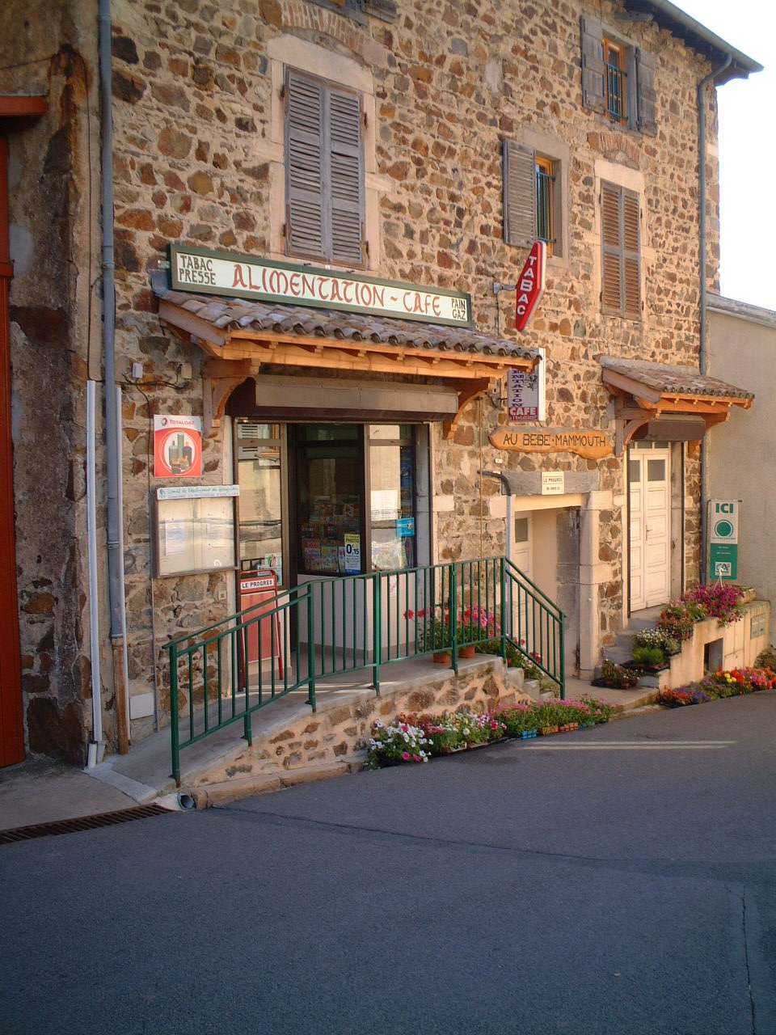
Next door is the village shop owned by Mr Goul and his wife - this is good for basics e.g. bread, butter, some fresh vegetables and the odd emergency item – he is also an expert on all things Marchampt and full of good advice if you are stuck. The shop opens about 8am – 12.30 and 3pm – 7pm. He is closed on Sunday afternoons and all day Monday. Mr Goul speaks some English if you are really stuck. Bread is delivered to him daily, best get there before 10.30am or it has gone (or is reserved). On Sundays he gets patisserie and they go really fast. If you particularly want something ordered ie daily croissant/pain au chocolat then he could probably do that for you. His cheese is good and his Beaujolais is very local and drinkable. He has a bar/cafe at the back of the shop – and a new terrace (which overlooks the far left hand corner of our garden!). The shop sells postcards and stamps, Marchampt
t-shirts…..but not fresh milk, only UHT. If you buy eggs there, take the empty box with you as he refills it. Empty egg boxes in the house in lower cupboard next to fridge.

The nearest boulangerie is in Quincié – the village you come through on the way into Marchampt. There is a small shop next to the church. This is the nearest place to buy fresh milk. The post office is here, our electrician’s wife (Lucette) runs the Electrical shop. There is a boucherie (butcher) and café too. Quincié is shut on Monday I think so you need to go further afield for your bread as Goul is also shut. Nice restaurant for lunch or dinner – you need to call in and book (see restaurants). Also good wine tasting Cave Co-operative – see Wine page.

Woodpile. In cooler weather the fire can be lit – wood pile is under vine covered shelter. Make sure flue is open, handle inside chimney. Please empty cooled ashes into bin.

Supermarkets: (See Maps)

In Belleville, just as you come off the autoroute, there is Intermarché which is open all day. Very close by is Champion another supermarket, also open all day and closes about 8pm. Good idea to stock up here when you arrive. All supermarkets have good selection of pre-prepared bbq meat.

In Beaujeu there is Shoppi, this is probably a little nearer than Belleville but we think this may shut for lunch.

If you want to shop big the two hypermarkets are in Macon Sud – Carrefour (our favourite) and Géant Casino in Villefranche. Both are about 40 minutes drive away. They have good cafeterias to have lunch between 12 and 2pm, any later and you’ve missed it unless you just want dessert and coffee. The food is good and very popular at lunch times. The other shops in these two commercial centres close for lunch.

Markets – See Book Tarragon & Truffles. I have just bought this book and haven’t tried it out yet. Big undercover market in Villefranche each Friday, Saturday and Sunday, fruit and veg – excellent with other stalls depending on which day you go. The market is in the town centre.

Nearby towns

Beaujeu is worth a wander. Anne de Beaujeu is a nice restaurant, there is a Huilerie (oil producer) down past the main shops, keep going out of the town and it’s on the right, great selection – good for foodie gifts. Belleville is a bigger town has a train station, many shops, restaurants and cafés. Villefranche has a Centre Commercial where the hypermarket is located, and fast food chains MacDonalds and Pizza. If you are planning on going to Lyon we would recommend NOT driving! Timetable of trains to Lyon at house. For shopping in Lyon get the train to Lyon Part Dieu, or Lyon Perrache for the old part of Lyon, by the river. (Street plan of Lyon at the house). Macon is a bit nicer than Villefranche as a town to wander around.

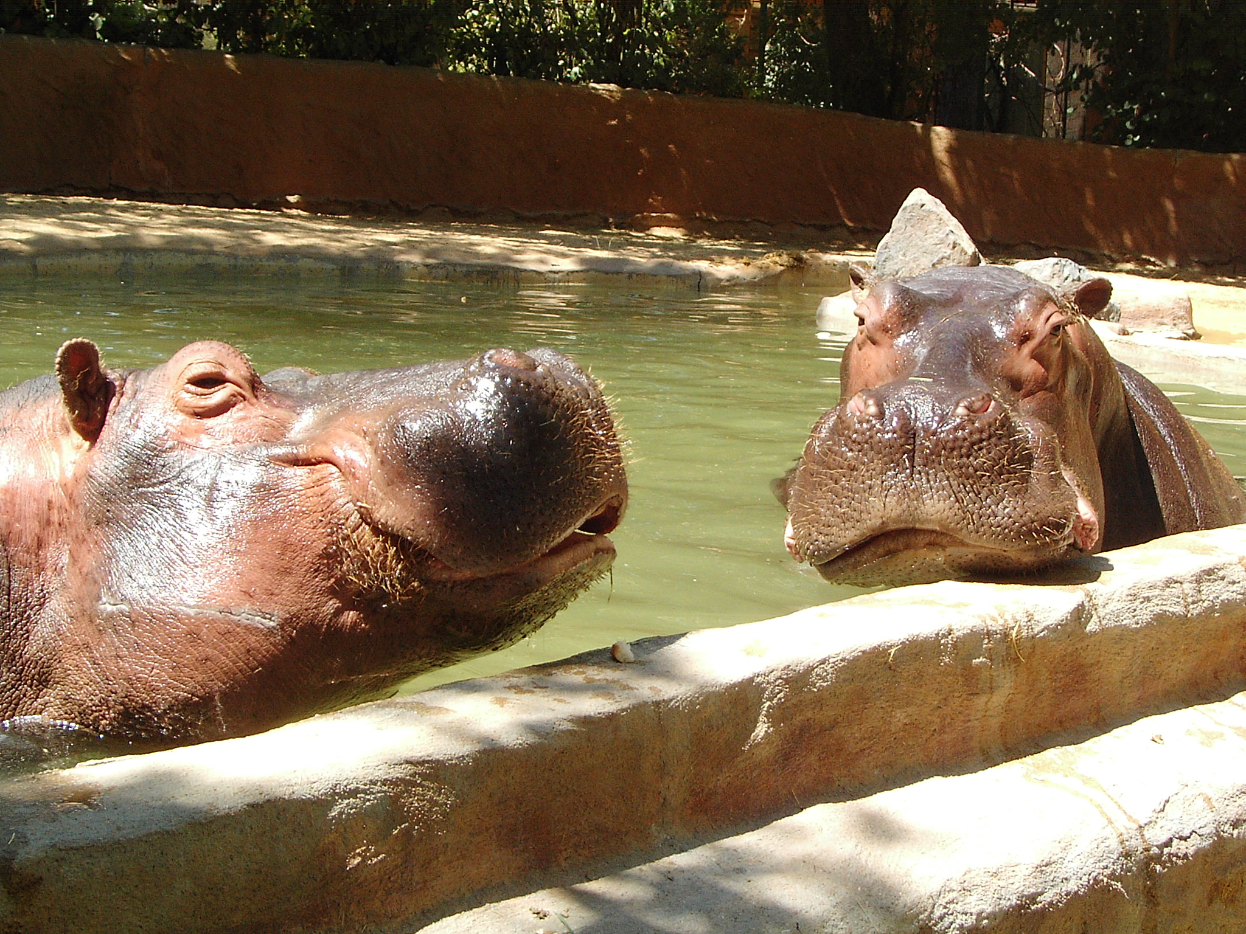
Touroparc in Romaneche Thorins is about 25 mins drive away, direction Macon. It is a really good day out. Nice, modern style zoo, lots of animals – not many cages. Water park too but remember to take your skimpy swimming trunks as they don’t allow boardies only Speedo style! There is a monorail, water slides, café. You can get a stamp to leave and re-enter the parc. There is a lake near Crêches sur Saône you can swim in, also fishing and pedalos for rent. (see Maps).

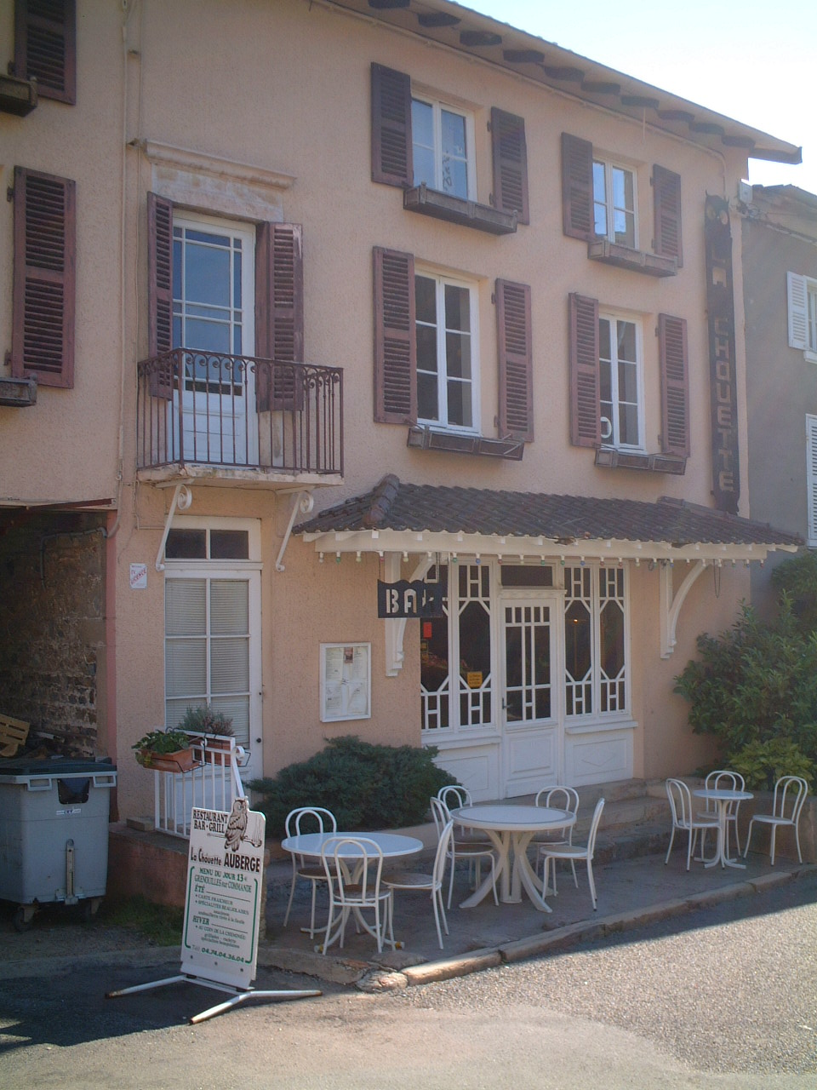
Bars & Restaurants – There is a bar/restaurant in Marchampt high up in the village near the church called La Chouette (see left) – very simple food, does lunches and evening. In Quincié – Auberge de la Roche - very good local food, need to book, again lunches and evening meal. Auberge des Samsons is on the road to Belleville at the roundabout to Odenas, its more long, lazy lunches. More casual in Fleurie two basic but very good lunchtime restaurants, near the church. Beaujeu has a Pizzeria on the left – eat in or takeaway and restaurant, Anne de Beaujeau, is much more upmarket. Belleville, Villefranche and Macon have MacDonalds and Pizza style fast food places.

Large Pottery in St Amour, close to the Cave Co-operative. Some iron work and lots of hand painted pottery. Pricey but certainly worth a look if you are in the area wine tasting.

Nearest petrol is a small station in Quincié but cheapest is at the supermarkets.

Nearest bank. Belleville at the crossroads (Credit Agricole I think)

Telephone Numbers

Sarah 0044 1242 241203
Mobile 07977 118325
John 0044 1242 241928
Mobile 07771 937210

Emergency Numbers
Hospital -
Doctor - Medical Practice in Cercié. Turn up without appointment mornings
Dentist -

Other Useful Numbers
Brittany Ferries 08705 360 360
Eurostar 08705 185 186
Eurotunnel 08705 35 35 35
P&O Ferries 08705 202 020
Rail Europe 08705 848 848
Sea France 08704 431 685

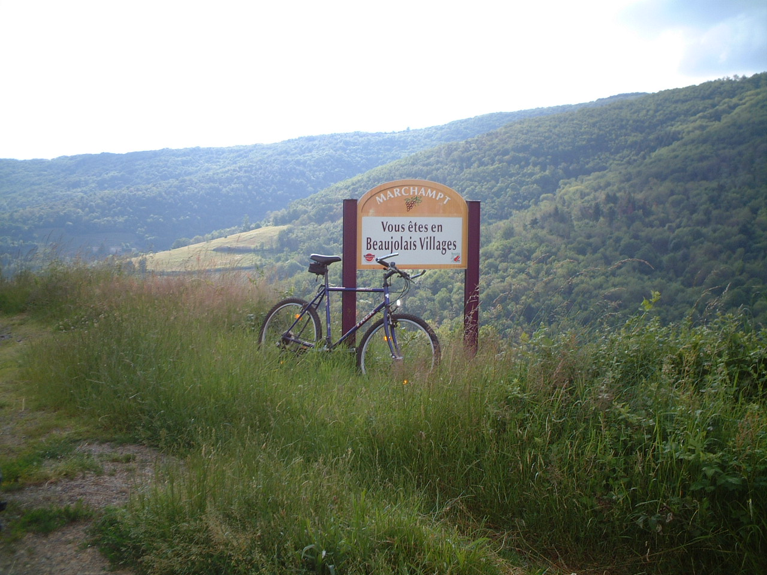
Other Information

